Assignment-25.6:

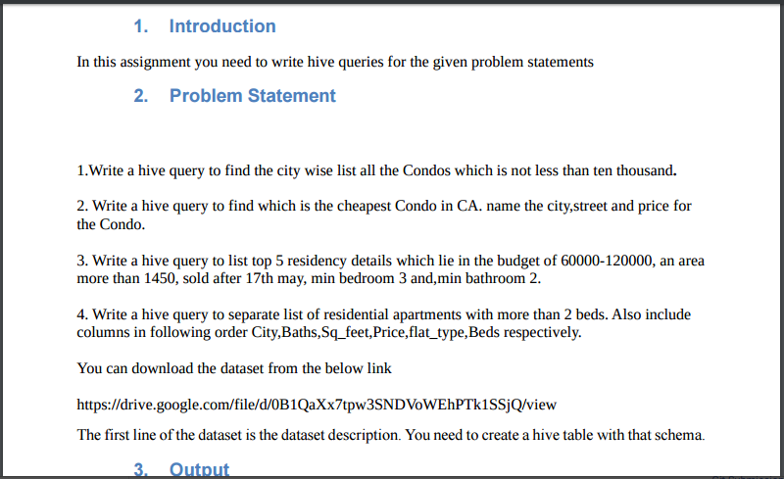

A table named realestate is created with the required columns and the data is loaded into the table. The contents of the table is displayed.

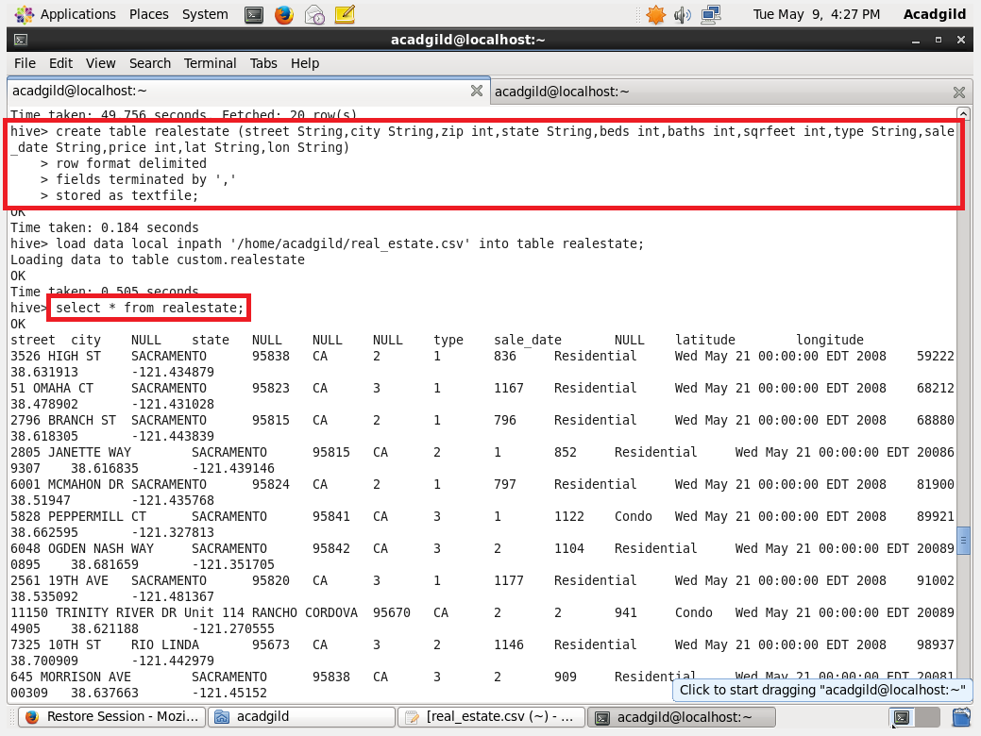

1. Write a hive query to find the city wise list all the Condos which is not less than ten thousand

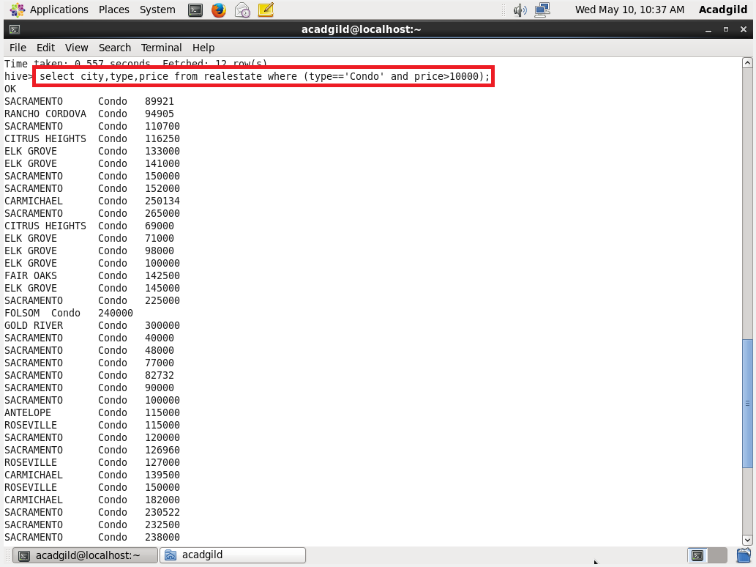

2. Write a hive query to find which is the cheapest Condo in CA. name the city,street and price for the Condo

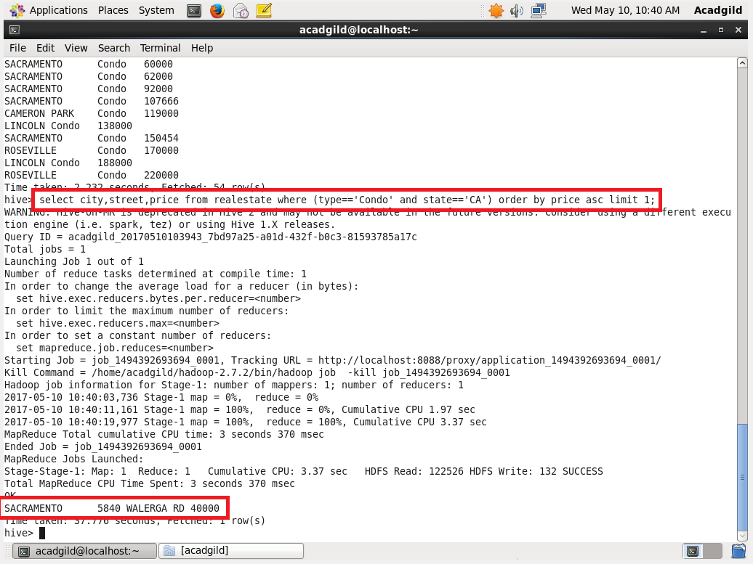

3. Write a hive query to list top 5 residency details which lie in the budget of 60000-120000, an area more than 1450, sold after 17th may, min bedroom 3 and,min bathroom 2.

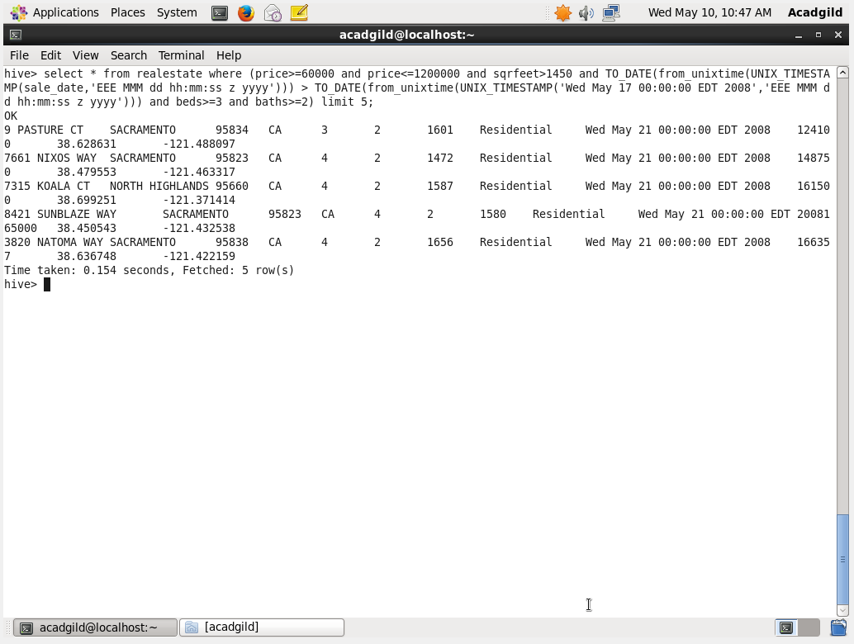

The **UNIX_TIMESTAMP** converts time string in format yyyy-MM-dd HH:mm:ss to Unix timestamp (in seconds). The **FROM_UNIXTIME** converts the number of seconds from unix epoch (1970-01-01 00:00:00 UTC) to a string representing the timestamp of that moment in the current system time zone in the format of "1970-01-01 00:00:00". The **TO_DATE** Returns the date part of a timestamp string. Then the dates are compared.

4. Write a hive query to separate list of residential apartments with more than 2 beds. Also include columns in following order City,Baths,Sq_feet,Price,flat_type,Beds respectively

